**MS302** **Project Report**



Akshay Vijay 2015019

Fakir Mohan Patra 2015086

Himanshu Somani 2015108

Deepak Chhipa 2015076

Supervisor: Dr. Sunil Agrawal

Solving scheduling problems using integer linear programming Method

**TABLE OF CONTENTS**

|  |  |  |
| --- | --- | --- |
| S.no | Topic | Pages |
| 1 | **INTRODUCTION** | 2 |
| 2 | **ABSTRACTION** | 2 |
| 3 | **OBJECTIVE** | 2 |
| 4 | **PROPOSED SOLUTION** | 6 |
| 5 | **CONCLUSION** | 8 |

## 

**Case Study – 01**

# **Research Topic**

# 

# “Using Integer Programming for Airport Service Planning in Staff Scheduling”.

# Author of the paper is W.H. lp, Nicl Chung, george Ho.

**Introduction:**

Nowadays, since air transport becomes more and more popular in the world, airline industry has been increasing rapidly on the demand of the aircraft service. As the worldwide air traffic is growing to unexpected levels, that causes the aircraft crew scheduling problem to become more and more complex and difficult faced by the aircraft company.

Enabling airport support services companies to achieve effective and efficient operations; accurate planning, scheduling and control systems are important and essential. It is difficult to find the optimal solutions since it involve many constraints and complex problems, such as costs minimization, meeting employee preferences, distributing equitably among employees and workplace satisfaction.

**Objective:**

Our Main objective is to provide an Integer Programming approach to determine the optimal solutions to aircraft maintenance planning and scheduling and hence the planning and Manpower Scheduling processes can become more efficient and effective.

Our main Focus on developing a scheduling system that can help airport support services companies to make decisions in providing the right staff in the right place at the right time.

**Literature review:**

* Cheung et al. (2005), experimented that in enabling airport support services companies to achieve effective and efficient operations; accurate planning, scheduling and control systems are important and essential.
* Ernst et al. (2004), experimented that it is difficult to find the optimal solutions since it involve many constraints and complex problems, such as costs minimization, meeting employee preferences, distributing equitably among employees and place satisfaction. He also stated that personnel scheduling is the process of constructing work timetables for staff so that an organization can satisfy the demand for its goods or services
* Bruker (2002), experimented that scheduling is concerned with the optimal allocation of scarce resources to activities over time.
* Bailey et al. (1995), experimented that The **Manpower Scheduling** algorithm is then used to determine the number of workers assigned needed to satisfy the demand. **Manpower Scheduling** is concerned with the scheduling of manpower resources to meet temporal operational requirements in ways that satisfy the goals and policies imposed by the management, labor union and the government.
* Souai & Teghem (2009) and Chang (2002) worked on solving the Crew Scheduling problem which is typically solved in two different stages. They are crew pairing and the crew rostering problems, where **Crew pairing problem** is to form a set of rotations, so that each flight segment or leg is covered at least once and the total cost is minimized. Besides, **Crew rostering problem** is to construct personalized schedules for airline crew members. That means it is a further allocation to individual crew.

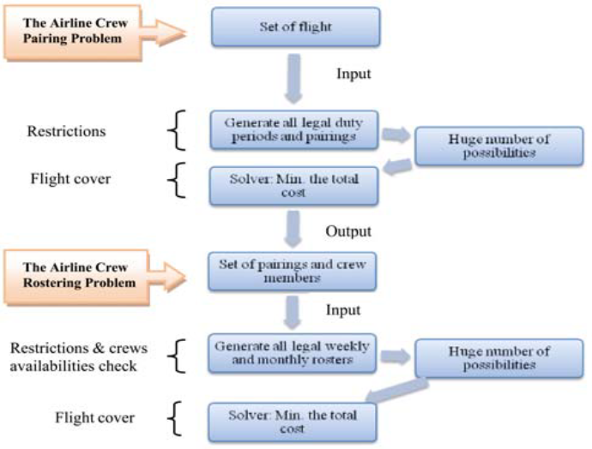

**Figure: 1**The illustration of airline crew scheduling process by Souai & Teghem (2009)

**Model Formulation:**

The formulation of the model is formulated according to the business nature of the studied company and is modified based on Haghani & Shafahi (2002). The notation would be defined as the following:

**Notations:**

F: Number of flights (f = 1 … F)

T: Number of unit maintenance time slots (t = 1 …T, each time slot is 2 hours)

G: Total number of maintenance groups (g = 1…G)

The earliest time slot for starting inspection for flight f

: The latest time slot for starting inspection for flight f

**Decision Variable**:

K(t) is a matrix for each time period t which indicated that whether a particular inspection can be performed in a maintenance group. The elements of K (t) are defined as follows:

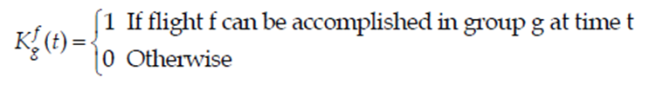

Group g has the license of flight f:

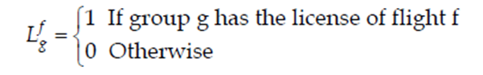

: is a matrix for each time period t which indicted **t**hat whether the inspection is working on flight f.

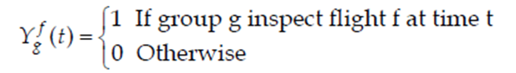

**Objective Function:**

The objective function is to balance the workload σ_gof each maintenance group. That means the variation of the total number of working time in each maintenance group should be minimized.

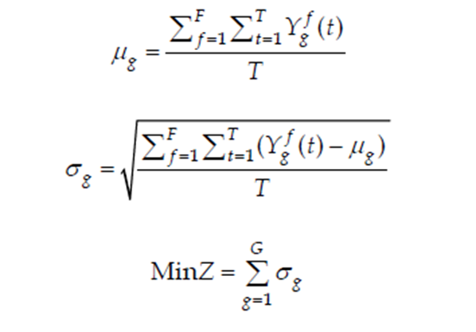

**Constraints:**

* Inspection should be started for each flight during its required time interval for that type of maintenance.

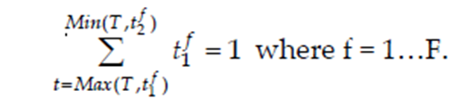

* Every flight must need to be inspected exactly 1 time which is two hours. Also, there is just one maintenance group allocated to perform inspection flight f during time period t.

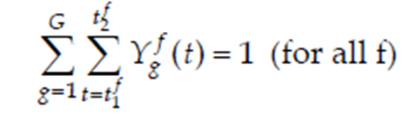

* A maintenance group can only perform the inspection with the corresponding aircraft licenses.

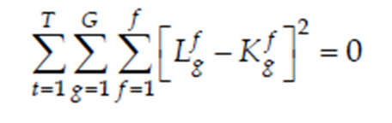

* A maintenance group with the corresponding aircraft license can only provide maintenance service for one flight at a time.

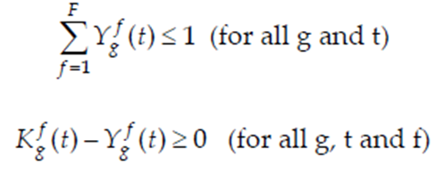

**Methodology:**

* To assign flights to the maintenance groups according to the time constraints and still fulfill the aircraft licenses requirement, Microsoft Excel Solver would be used for solving the integer programming.
* Solver is part of a suite of commands sometimes called what-if analysis tools which is a process of changing the values in cells to see how those changes affect the outcome of formulas on the worksheet. With Solver, an optimal value can be found for a formula in the target cell on a worksheet. Solver works with a group of cells that are related, either directly or indirectly, to the formula in the target cell. Also, solver adjusts the values in the changing cells which specified (adjustable cells) to produce the result you specify from the target cell formula.
* To assign flights to the maintenance groups according to the time constraints and still fulfill the aircraft licenses requirement, Microsoft Excel Solver would be used for solving the integer programming.
* Solver is part of a suite of commands sometimes called what-if analysis tools which is a process of changing the values in cells to see how those changes affect the outcome of formulas on the worksheet. With Solver, an optimal value can be found for a formula in the target cell on a worksheet. Solver works with a group of cells that are related, either directly or indirectly, to the formula in the target cell. Also, solver adjusts the values in the changing cells which specified (adjustable cells) to produce the result you specify from the target cell formula.

**Result and Discussion:**

* After reviewing all the results, all the cases can be obtained optimal solution. Although there are some variables that cannot become binary number, optimal solution is reached since the workload of each group is balanced and all the constraints are fulfilled after n rounding up. Moreover, the computation time is reasonable and acceptable since the total computation time of a shift is only 53 sec.
* The maintenance personnel allocation would be different in peak and non-peak time comparing with the peak and non-peak time, since the number of flights which need to be inspected would be reduced and the staying time of each flight is longer, the number of teams should be reduced in order to increase the utilization of each inspector.

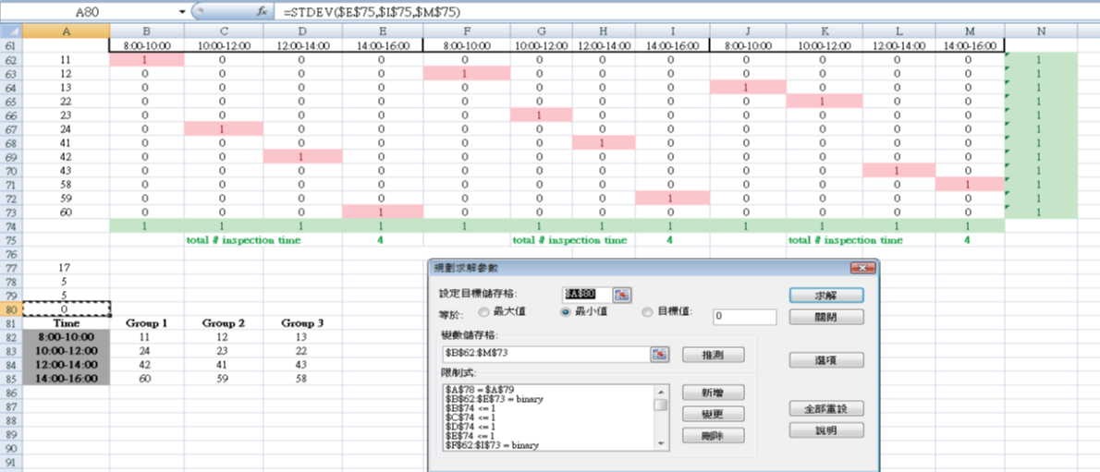

**Figure: 2** Illustration of the objection function

**Conclusion:**

This paper proposed an optimization approach to improve the manual maintenance scheduling process. Since scheduling would split up into different stages studied in the literature, different mathematical techniques should be adopted to cater for their own problem characteristics. There are 3 stages for solving the aircraft maintenance scheduling problem. They are initial maintenance demand schedule, the maintenance pairing and the maintenance groups assignment in a sequential way.

**Case Study - 02**

Generating an Optimal Employee Work Schedule Using Integer Linear Programming

### **Contents**

* 1. Read in the requirements and employee data from the Excel sheet
* 2. Generate the f, A, and b matrices based on the the constraints and objectives
* 3. Call intlinprog with every variable as an integer 0 or 1
* 4. Gather and display the results
* 5. Conclusion

**Given**

* A list of employees with their available work hours, and hourly salaries and minimum, maximum hours for which they can work
* A prescribed minimum number of staff needed to be at work at a given hour (fewer staff are needed at night, more staff are needed during peak hours)

**Find a schedule which MINIMIZES:**

The total daily wages the employer must pay out to his employees.

**While meeting the hard CONSTRAINTS:**

* At any given hour, you must meet the minimum staffing requirement
* An employee can only work one shift a day
* An employee must work within his available hours
* If an employee is called for duty, they must work at least a specified minimum number of hours, and no more than a specified maximum number of hours

This is probably a bit abstract, but let's load in some concrete data so you can get a clearer idea of what exactly we are trying to do here.

#### **1. Read in the requirements and employee data from the Excel sheet**

The staff information and scheduling requirements are in an Excel file, so we will first need to import the data.

The first sheet in the Excel file contains the staff information, and it is in a tabular format suitable to be imported directly as a MATLAB table using the read table function.

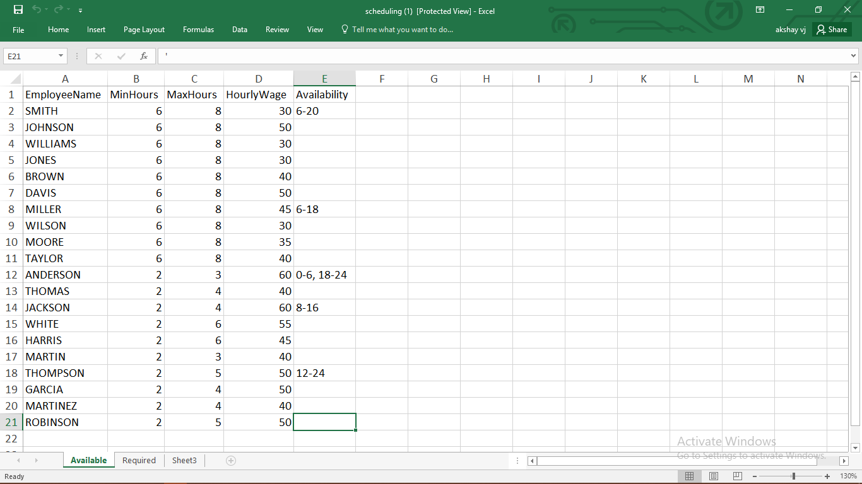

**Figure: 3** Data of the Staff

* The variable staff Table has a list of each employee, along with the minimum hours they must work (if they are called in), maximum hours they may work, their hourly wage, and any limits on availability if there are any.
* For example, the first employee SMITH, if called in, must work at least 6 hours, no more than 8 hours, earns $30/hour, and is only available between 6am and 8pm.
* We can also see the required staffing requirements for each hour of the 24-hour day. I don't need this to be table, we just want to import it as a numeric array, so “xlsread” will work just fine.

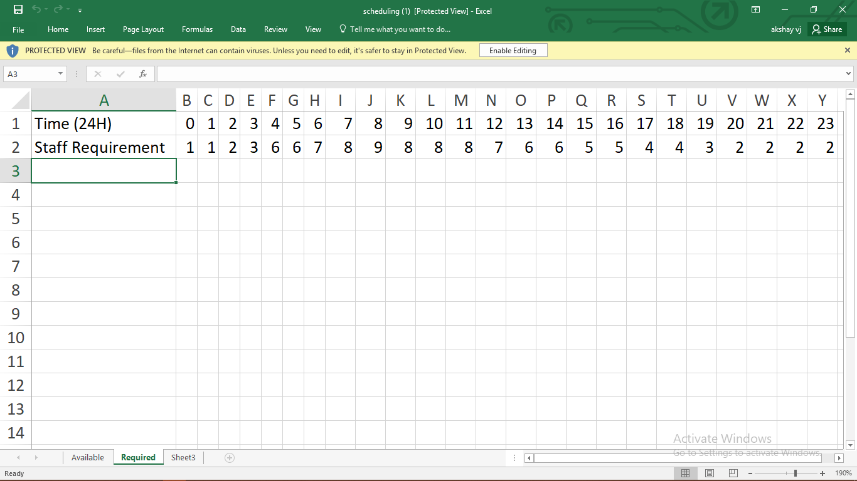

**Figure**: **4** Required staffing (hourly from 0:00 - 24:00)

* Late at night, only 1 or 2 employees are needed, while during peak hours in the morning to afternoon, we may need as many as 9 employees on duty.
* However, we do want to discuss briefly the structure of the constraint matrices and decision variables for this particular problem. Let's take a look at the constraint matrix **A**. Here we used the spy function to view the sparsity pattern.

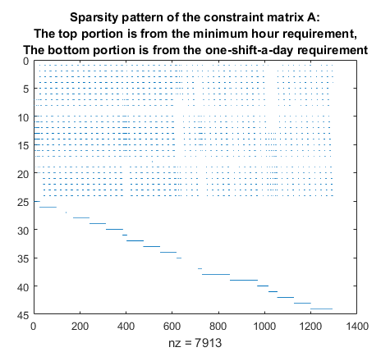

* There are two parts to the inequality constraint matrix **A**, which are clearly visible. The top portion has 24 rows (because there are 24 hours in a day) and each row represents the constraint that at a particular hour, you need a minimum number of staff.
* The bottom section of **A**, in this case, has 20 rows (because there are 20 available employees). The k-th row of this section is associated with the constraint that the k-th employee may only work one shift per day.
* **A** will in general be much wider than tall, and the columns of **A** represent every possible shift for every possible employee. Every column of **A** is also associated with a decision variable that we constrain to be either 0 or 1 (a binary variable).

X = [, , , ……..]

for all n

* A value of 1 for means that that n-th shift possibility is implemented, and a value of 0 indicates it is not. For this particular problem, **A** has 1295 columns, and so **x** is a decision vector of length k = 1295. It is this **x** that intlinprog will solve for.
* As the number of employees and possible shifts increases, **A** may consist of many thousands of columns. Although I didn't use sparse matrices in this demo, intlinprog is capable of working with sparse matrices to make more efficient use of memory and allow for larger problem sizes.

#### **3. Call intlinprog with every variable as an integer 0 or 1**

Once the relevant matrices are created, all that's left to do is actually call intlinprog. I specify that all the decision variables are integers, and have a value between 0 and 1.

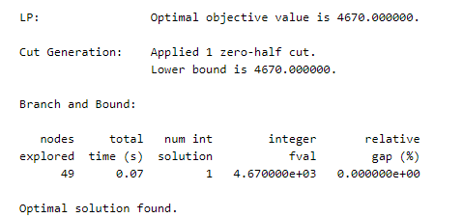

#### **4. Gather and display the results**

Intlinprog will give me my optimal x vector, but this is simply a long vector of of ones and zeros saying which shifts are implemented. I will go back and find out which index of x corresponds with which employee and shift, and then display the data in a more human-friendly form.

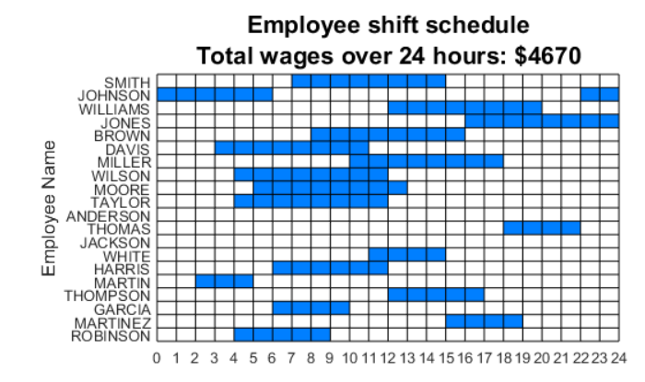

This plot shows the actual work schedule for each employee (blue indicates when on shift). Note that there are a couple of employees (ANDERSON and JACKSON) that do not get called in. Also, while it seems that JOHNSON has two shifts, this is because we are wrapping around and the shift actually goes from 10pm to 6am the next morning.

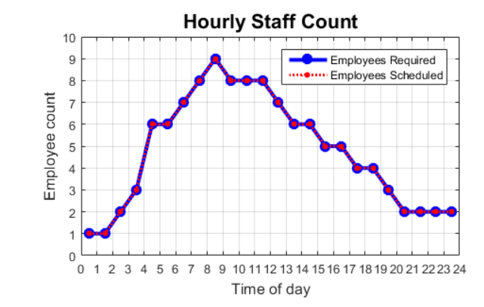

This plot shows the number of staff on duty as compared to our minimum staffing requirements. We see that we meet the requirements exactly, without overstaffing or understaffing at any point. This makes sense, because if the goal is to minimize paid wages, then you'd try to stay as close to the minimum staff as possible.

#### **5. Conclusion**

The problem outlined in the example is not a trivial one to solve. To be sure, it takes a bit of study and experience to be able to know how to easily convert a real world problem into its equivalent MILP formulation.

But for problems like this, especially at larger problem sizes, attempting to solve it using other methods such trial-and-error or genetic algorithms will usually take longer, and generally not yield as good results.

**GROUP PHOTO:-**



Top left:- **FAKIR MOHAN PATRA,** Top Right:- **HIMANSHU SOMANI**

Bottom Left:- **AKSHAY VIJAY,** Bottom Right:- **DEEPAK CHIPPA**

**THANK YOU**